Monacello
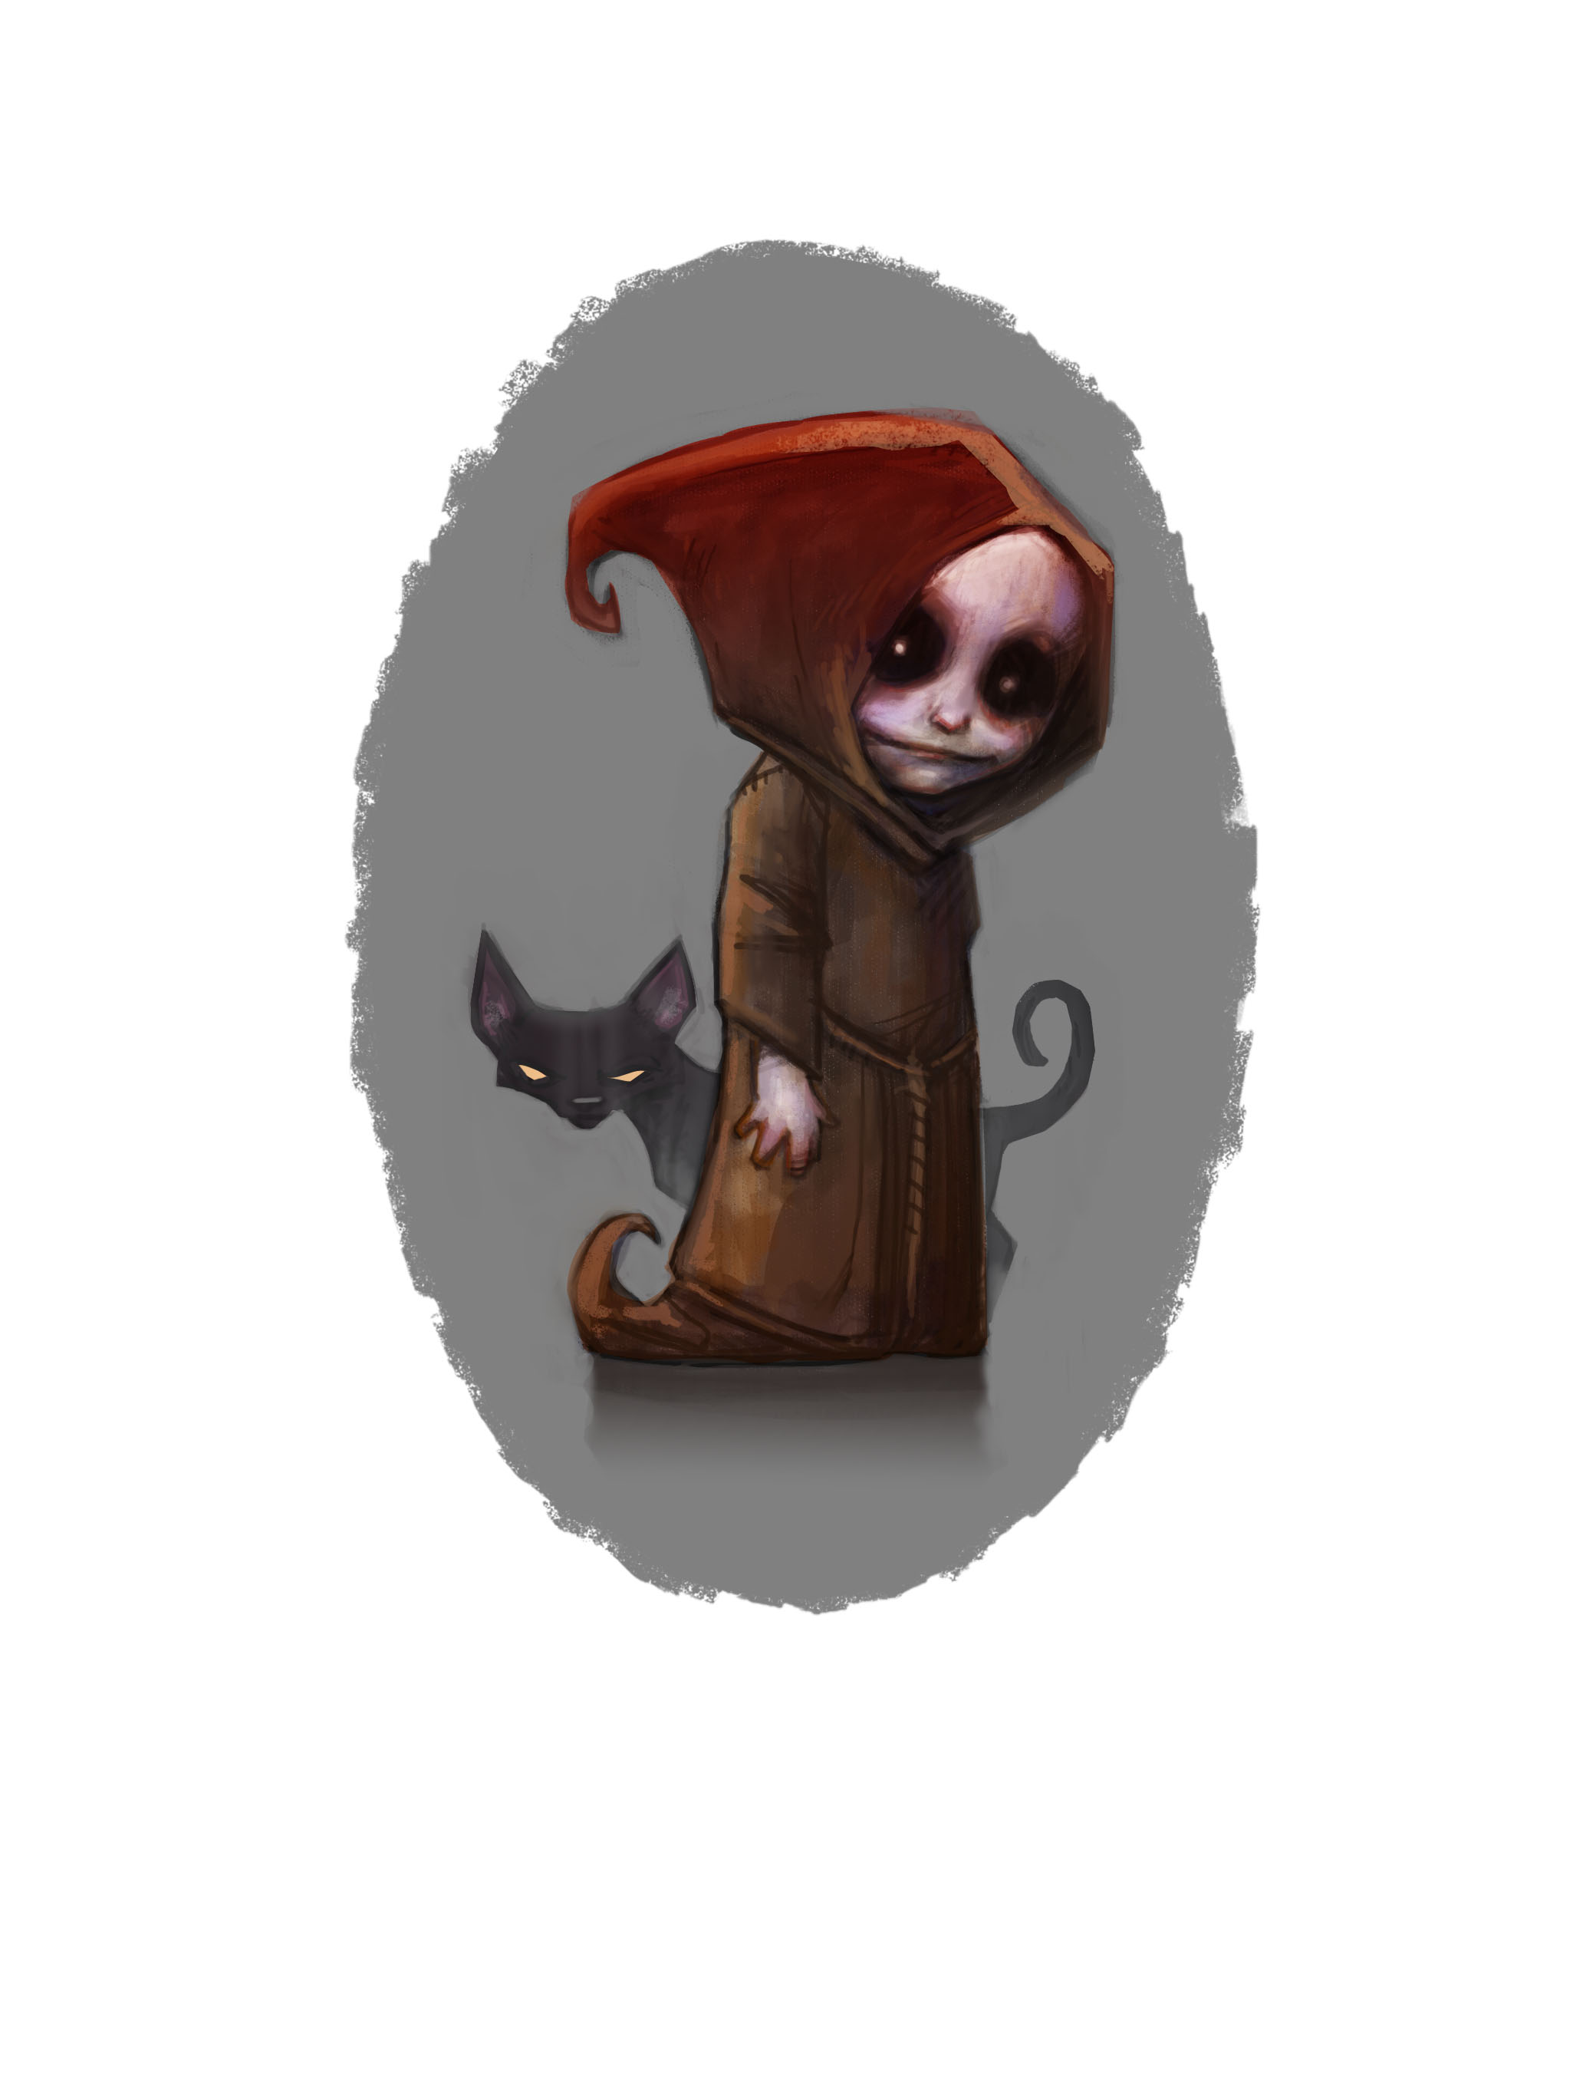

Anything but Perfect

Chapter One

“Monacello is dead! The Bad Luck Boy is dead!”
The Frezza brothers chanted it through the streets. The city of Naples caught its breath. Could it be true? Was he truly gone, the strange, bent little creature who for years had haunted the lanes of Naples and walked the city’s rooftops at night?

Should they be sad or glad? One glimpse of Monacello, and bad luck seemed to fall on your head, as sure as droppings from a seagull.
There again, if the Little Monk came in sight and you spoke a wish, sometimes the wish came true.
“How did he die?” the people asked.
“We wished him dead,” said the Frezzas, “then we buried him!” and joy seethed in their eyes like molten lead.
They were wrong, of course.

Monacello had slipped away, like a hunted fox, and gone to earth deep below the city. There he sat and licked his pale lips, tasting bitterness.
He thought of turning his back on Naples and setting out on his Great Search. He dreamt of his Great Search as an explorer dreams of discovering a new land. The Frezza Brothers had thrown a lot of things at him over the years - rotten fruit, clods of mud, bottles and boots and curses that bruised his heart. But just once they had thrown a story at him - a fearful story: the story of Monacello’s father.
(Ever since he was old enough to walk, Monacello had scoured Naples in vain for the mother he had never known. He had never given a thought to having a father!)
They had snorted and sniggered about a young fool in love with their sister – said they had threatened him with death - said they had made him run away, leaving everything behind

- even his baby son, apparently.

What delight the Frezza boys had taken in telling Monacello about the time they kicked and cuffed and cursed his father out of the city.
But Monacello would find him! He would dog his father’s footsteps through the great world, doing whatever he must: sailing oceans, scaling mountains, sifting the desert sands… Part of him knew it was hopeless - who can find a stranger among Everybody Everywhere? But planning it kept him almost as warm as an eiderdown of cats.

Sometimes his cats still insisted on taking him out, after dark, to skitter about the city streets and skyline. Whispered wishes blew by, but Monacello brushed them aside. Deep puddles of bad luck lay in the streets for anyone to step in – but Monacello had not put them there. He was too busy planning his Great Search.
No, Monacello did not go looking for trouble. Trouble found him all the same.
His friend Napolina fell ill. Down in the Undercity, she lay on her bed of rags, pale as candle wax. And every day she grew more ill.

Monacello gave her his cats for a blanket – Wormy and Fleahouse, Hairdrop, Admiral and the rest. The littlest kitten sat on her chest even now, gently rising up and down. But though cats are as warm as feather bedding, Napolina still shivered.

Monacello stole candle stubs from the church overhead,
but their flames could not chase the shadows out of her face.
He knew he could not leave her. She was a friend, and friends are more important than searches or hopes or dreams.

“Tell me the news in Naples,” she would say, and Monacello talked of happy things: palios and marriages, circuses and miracles – to cheer her up.
Then Napolina would said, “Now tell me the truth.”

And he had to tell her about rats infesting the houses, a failed harvest, another rise in the price of bread, fruit in the orchards that did not swell because the yellow clouds never, ever rained.
There was even rumour of a War looming.

One day the Grand Duke of Naples boarded a ship and sailed away without a word, just when the city needed him most.

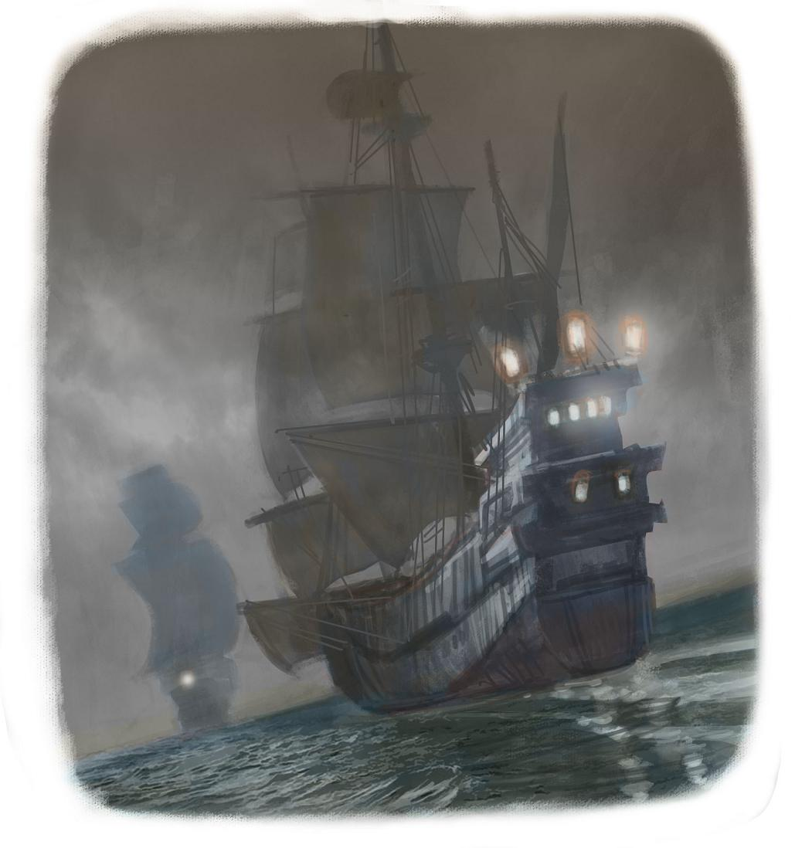

The scoundrel Fippo Frezza moved into the Grand Duke’s grand palace, high on the hill, along with his sneering brothers.

Townspeople came and rattled at the palace gates, asking, “What should we do about the rats?”
“… the harvest?”
“…the drought?”
“Tell us! Advise us!”
Fippo went out to them, wearing the Grand Duke’s robes, and told them, “Scout about. Help yourselves to whatever you can find.”
So now, every night, roaring mobs roamed the streets. Looters.
Truly, Naples had no need of Bad Luck Boy, Monacello; Naples had bad luck enough for the whole of Italy.

Chapter TWO
In search of a peach

As the city overhead suffered worse and worse hardships, so down in the Undercity, Napolina grew more and more ill.
Monacello tried to wish her better, but his wishes held no magic.
“If I only had my caps, my magic caps!” he wailed. “Fippo Frezza took both my caps and now I can’t wish you well!” He began to panic. The cats felt his fear, and their tails flicked with unease. “What can I do? There must be something I can do!”
Napolina opened her pale eyes. “Go and find the end of your story,” she said. “You promised you would, and that is all I want… though a peach might be nice, too.” And she licked her dry lips.

A peach? In a city where rats fought over a cabbage stalk?
A peach? From orchards dry of rain? Impossible!
And where does a boy go looking for his life story? Even the nuns who had found him on their doorstep as a baby, did not know his name or where he had come from.

The streets were full of people. Flaring torches lit angry faces and clenched fists. A mob was roaming the night city, as Fippo Frezza had told them to do.
Monacello and the cats kept to the rooftops, out of range of the torchlight. And in jumping across a factory skylight, Monacello looked down and saw… a perfect peach!
*
The treasures inside the Capo de Monte Factory enchanted him. Flowers bloomed, petal-perfect; doves spread feathery wings; luscious fruit lay in milk-white bowls.

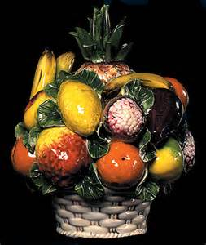
…But everything was cold to the touch – a
porcelain piece of pretend.
Monacello put a single peach into his
pocket and…
- oh, do be careful, clumsy Monacello!
Look where you’re going, cats!
Don’t knock… don’t nudge… don’t
break… mind that… watch out for
…ooo! for goodness sake don’t -

…amazing to say, reached the front door without mis-hap. At least now he had a peach for Napolina!

“It’s the Good-Luck-Bad-Luck Boy!” cried the mob filling the street outside, blocking his escape. “Not dead after all!”
“Quick, let’s make a wish!”
“Make it rain, Wish-Bringer! Put food in our bellies!”
Monacello shook with fright. His hand rose to his head, but - no cap. All his life he had worn red or black, one or the other. Red for wishes, black for mischief.
“I c-can’t,” he said.
The mob snarled. The mob roared. “He’s keeping all the luck for himself!”

Monacello fled back into the factory ...but the mob came after him, with a noise of smashing and crashing, splintering and disaster – the noise of Beauty shattering into a million smithereens.
The cats scattered. Monacello ran. The mob came after him, cursing the kittens that tripped them up.
“Death to the Little Monk!” they shouted. “He poisoned our luck!”

One or two still threw wishes, though, and that was worse. The wishes broke over Monacello’s bare head like porcelain:
“Wish bringer! My children are hungry!”
“Wish bringer! Help our beloved city!”

Chapter THREE
A PICTURE OF HATE

Was it to escape the hate or the wishes that Monacello squeezed through the iron gates of Villa Frezza? His rope belt caught on the metal bars. The knots he had tied in the rope pulled a little tighter. Remember, said those knots. Remember what the Frezzas did to you. Remember how they wished you dead!
His cats caught him up, springing easily over the high garden wall. In every tail was a knot. Remember, said those knots. Remember that the Frezzas beat your father out of Naples!
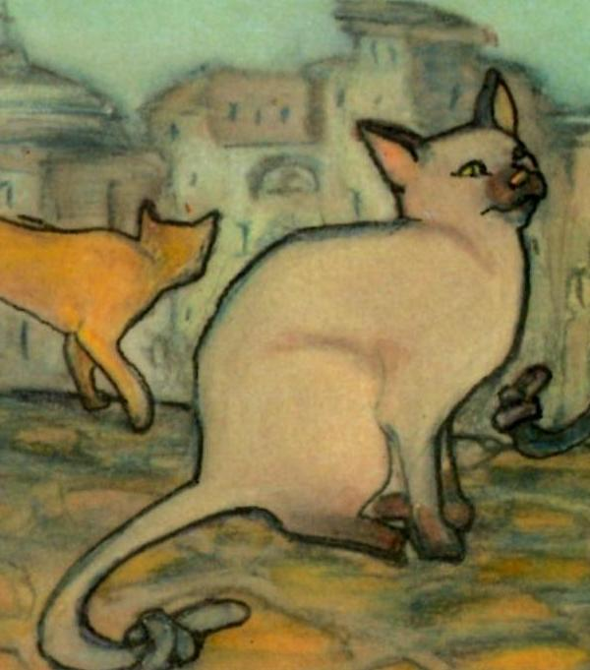

Fippo and his loutish brothers had moved to the Duke’s Palace, but Old Man Frezza still lived here, at Villa Frezza. He sat dozing in his chair, old age shawling his shoulders, like a great, grey cat.

The room was filled with beautiful things – paintings and lamps, tapestries, furniture and ornaments, all bought at huge expense. But all over the floor, swelling like boils, lay dozens of rotting peaches, green with mould, grey with mildew, oozing yellow slime.
So many peaches, and all their sweetness gone to waste!
At the top of the bookcase, two dirty folds of red-and-black caught Monacello’s eye. His caps! The caps the brothers had stolen from him!
If he could just creep past the sleeping…

Clumsy little Monacello!

“My caps! I was only after my caps!” cried Monacello scrambling up the bookcase.
Below him, Old Frezza – awake and raging - took aim. Vases and snuffboxes, candlesticks and books thudded against the wall and bookcase. “Die, devil, and be done!”
Ever since he could remember, Monacello had been hated.
But never in all his little life had he seen hate like this. It purpled the old man’s cheeks and made his white hair quiver.

“Why, Signor Frezza? Why do you hate me?”

“Ugly!” gasped the old man. “I won’t have Ugly! I want nothing in my house that is not perfect! And look at you!

“All my life I have tried to grow the perfect, unblemished peach – my sons bring them from my orchards – ‘Look, father – here’s one, look!’ - Huh! Useless whelps. Never a one that is truly perfect. I KNOW perfect! I had a daughter once! I KNOW perfect!

“A perfect daughter, loving and lovely. Clever and kind,” said Old Man Frezza. “A match fit for the Duke himself!” For a moment he sounded almost tender. The moment soon passed. “And who did she choose to love?
A penniless sculptor! A nobody! He wormed his way into her heart like a caterpillar into a peach. I forbade her ever to see him again! She defied me – can you believe it? Crept out and married him in secret! Call that a marriage? I would have found her the ideal bridegroom! I would have given her the perfect wedding!
“I knew nothing of this so-called marriage - not until my sons caught the wretch one night, climbing down from my daughter’s balcony. They made him pay, alright! They kicked and cuffed and cursed him out of Naples. Good riddance! Dirty little sneak-thief, out to steal my daughter’s heart!
“Was she grateful to me? Not one bit! She turned as sour as lemons. Rotten as a bad peach. Wouldn’t speak to me. Never smiled at. That’s not pleasing in a woman. A frown makes a woman …less than perfect. Some days she was almost ugly.
“Worse! – the ungrateful girl got sick! That slender little waist of hers swelled until she was round as a barrel. Not pleasing. Less than perfect, you see? One day – without even asking my permission - she gave birth to a baby
…and died doing it.

“And what was I left with? Some pretty child who took after its mother? No! No such luck! Something perfect? Huh! A hideous brat, pale eyed,
body bent like a question mark. All crumpled and smudged.
I tell you, I won’t have things in my house that are not perfect!
“Give it to the nuns at the convent! said I. They can forgive ugliness.
And look what it grew into: that ugly blot, that mistake. It grew into YOU!”

“Your daughter was my mother?” Monacello’s lungs emptied as if he had been sat on. “I knew my father loved her. I knew Fippo drove him out… But now you saying... The sculptor was my father? That bully Fippo is my uncle? And YOU are my grandfather? You broke my mother’s heart, then threw me out like rubbish!”
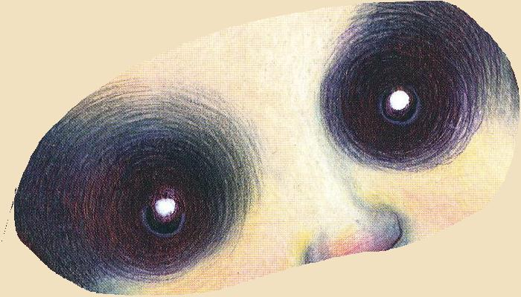

His pale eyes flashed
and every clock in the house stopped, dead.
The chandeliers crashed to the floor. The pictures slid to crazy angles. Windows cracked. Tiles cascaded from the roof and smashed in the garden below. Logs rolled out of the fireplace.
In terror, Old Man Frezza snatched up one of the burning logs and brandished it. “That’s true. That is so. But tonight, I shall finally be rid of you!”

Monacello blinked and blinked again. “But I am your...”
“Never! Look at you! Nothing of mine is less than perfect!”
Monacello dodged the flames jabbing at his face. “What about your sons? All three of them are horrible!”
“Yes,” Old Frezza retorted. “Perfectly horrible, as I raised them to be. I own nothing that is not perfectly as I want it to be.”

Monacello stopped dead, then, and put his hands on his hips.
“Well, you do now,” he said.

“You have me, like it or not. I can’t stop being your grandson. Anyway: nobody’s perfect – not even you.”
“Me? You dare to say this to me, you ugly little smut?”
But Monacello only pointed to the mirror on the wall.
One look showed the reflection of a man shrivelled by age, ugly with rage - a sour, yellow-skinned old man. Even to himself, Old Man Frezza looked like a rotten peach. The log fell from his hand…


Its flames clambered eagerly up the curtains, engulfing the room in fire.

Monacello crammed the red cap on to his head. He made a wish.

What did you wish for, curious boy, shaped like a question mark, in your red
wishing cap? To be revenged on the cruel Frezzas for all they have done to you?
To turn back Time and change the Past?
To be perfect?

Chapter FOUR
WHAT MONACELLO WISHED FOR

From the four corners of the sky sailed fleets of black cloud.
They collided over Naples with a deafening roar of thunder.
Rats in the streets were stunned to a stillness then sluiced squealing away by a cloudburst.
Rain fell so hard that it burst through the broken windows of the Villa Frezza, through the holes in its roof, dousing the paintings, ornaments and furnishing, dousing the old man and boy, drowning the flames.



The fire went out with a hissss.

Meanwhile, fountains overflowed and drains choked.
Wind and rain set church bells swinging and clanging.

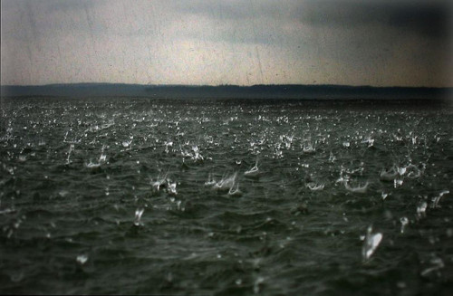

The sea’s waves, too, were hammered flat.

Foreign ships on the distant horizon turned and ran for shore, beaching themselves in the bay, spilling their cargoes of rice and cheese, pickled beef and lentils.
The storm soaked the thirsty fields and dusty town, so that colours sprang back to life. The mob rushed up and down, hands outstretched, clutching at the rain. Though they shivered with cold, though they staggered in the deep puddles, flinched from the lightning and yelped at the sharp rain, they also laughed out loud. For surely the drought and the famine were over!
Some, who had wished on the little Wish Bringer, looked around to thank him. But Monacello was nowhere to be seen. He was still with his grandfather in the Villa Frezza.


Monacello reached into his sodden pockets and took out the china peach. He held it out to Old Man Frezza.
It had no blemish.
It would never rot.

But it did not make the old man smile. He took it and crushed it in his fist. “Not real,” he snarled.

“I know,” said Monacello. “And it has no sweetness or goodness in it. That’s why it won’t do. But I can show you ‘perfect’, if you like.
Do you want me to?”

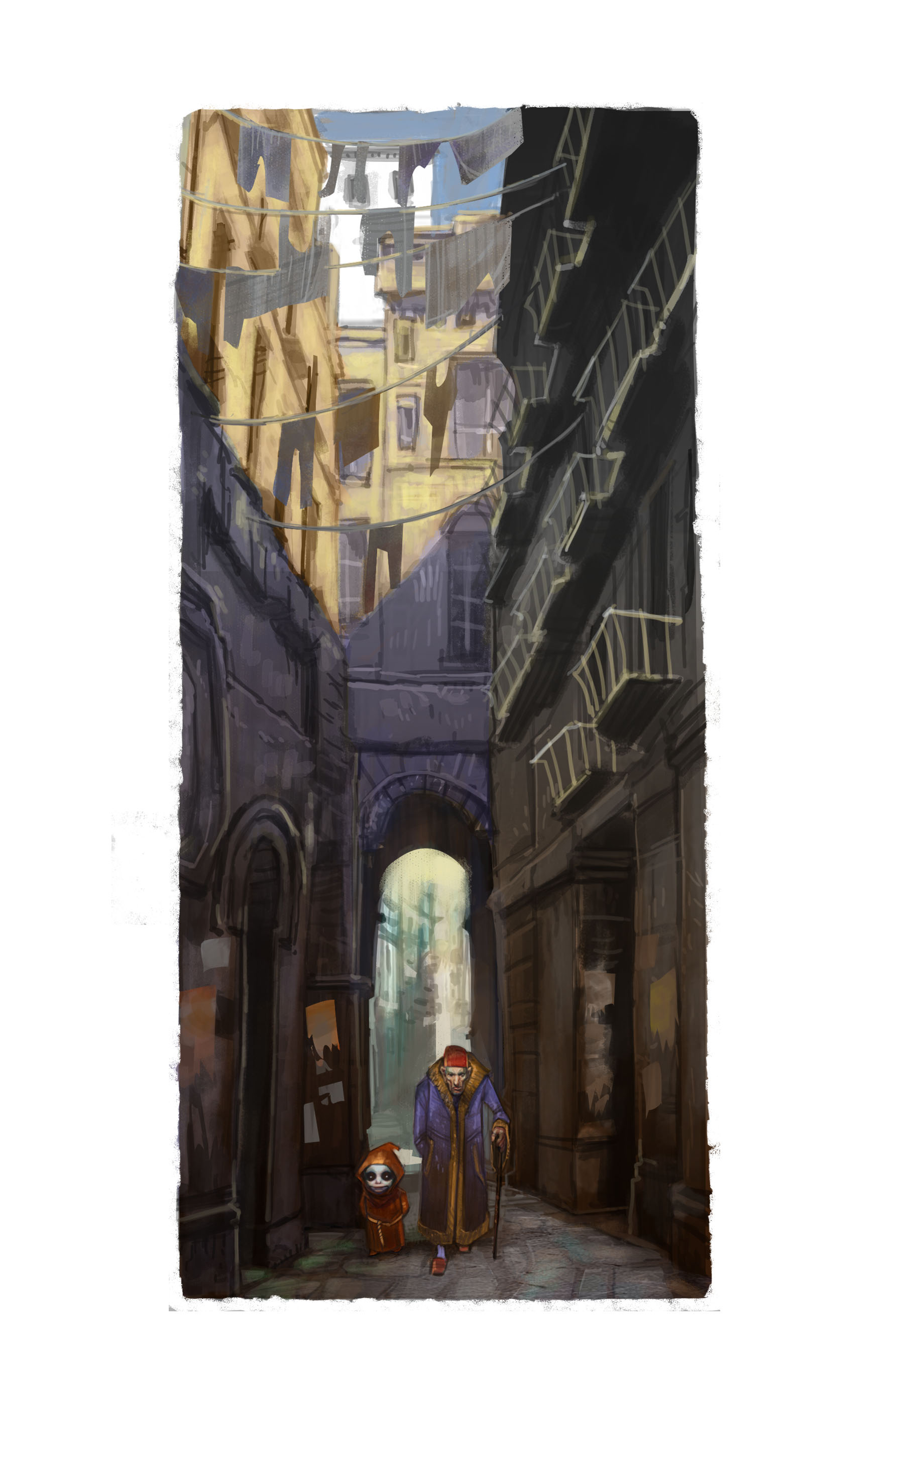
He led the old man to the Church of Santa Chiara.

The storm had blown out all the candles.

“Call this perfect?” snorted Frezza. “Huh! There are cats all over! And just look at these statues: noses chipped, paint faded. That wretch your father carved one of these – yes, that one there. ‘The Spirit of Naples’ he called it. Said he was inspired by my daughter… Nonsense! It is nothing like her!”
“Of course not,” said Monacello mildly. “It isn’t real. This isn’t what I brought you to see. We haven’t got there yet.” And he led the way through the church and out again, to a big sepulchre – a tomb - and through its marble door to the dark inside. In the darkness, the floor sloped steeply…
Old Man Frezza began to tremble with fright. “Where are you taking me, boy? Down to Hell?”

“To the Undercity. There is someone I want you to meet.”
But as they descended the tunnel, there was a noise of rushing water.



Rain from the storm was cascading down into the city’s basement. It washed over their feet. Was the Undercity even now filling up with water? Flooding the Roman ruins? Swilling over the mosaic floors? Drowning the room with the sun on the wall, even drowning…

“No, no!” Monacello began to run. He had not thought of this when he wished for rain!
When the water reached their bellies, the cats cringed, too afraid to go on. Monacello gathered them into his arms and splashed onwards.
“Slow down! I am an old man, I cannot keep my footing!” whimpered Old Man Frezza. “It is so dark!”
But Monacello could not wait. “I should not have left her alone! When I wished, I should have thought… It will all be my fault if…”


A lit candle came floating by
– and then another.

Before he reached home, Monacello was waist deep, the passageways of the Undercity rippling with light. One more bend and they would be there…

*

“Why do you show me this girl?” moaned Old Man Frezza. “Because she looks like that statue in the church? My daughter never wore rags! My daughter never lived underground like a sewer rat!”
Monacello’s laugh echoed through the mazy magnificence of the Undercity. “I am showing you my friend Napolina, because she is a perfect person - and ‘perfect’ turns up in the oddest places. Are you well again, Napolina?”
“Of course!” said the girl sitting, afloat, on his table, radiant amid a host of candles. “Whenever Naples is well and happy, so am I. …I see you found your story, Monacello.”
And Monacello had the strangest feeling that she had known it all along, right down to the last full stop.
*

Fippo Frezza stood in the open window of the Grand Palace and addressed the damp crowd outside.
“You see how I fixed everything? – How I made it rain? How I put food on your plates again, and water in the wells?”
Everybody clapped.
“From today I shall call myself Grand Duke Fippo of Naples!”
Again, the people cheered.

But one more ship had sailed into Naples Bay during the storm.
It carried the Grand Duke himself. From the back of the crowd he spoke up now:
“Men and women of Naples, I am sorry I left you at such a time, but I went to make peace with the enemy. I am glad to say we shall be spared the greatest suffering of all: the sorrow of War. I am glad too to say, I am back.”

Fippo swaggered up to him, nose to nose. “Oh yes? Oh yes? Well, who saved the city from drought and hunger while you were away enjoying yourself? Who stopped all the bad luck goblin Monacello began?”

Suddenly, through the cheering crowds hobbled a crooked figure, muttering and sputtering, elbows jabbing. “Out of my way, out of my way!”

It was Old Man Frezza.

“Duke of Naples, indeed,” he chuntered. “This one couldn’t save a cabbage from a slug. God and the Wishbringer saved Naples… and the Wishbringer was only trying to put out the curtains!”
Then he took hold of Fippo by the ear and marched him away home.

Chapter Five
the visitor

There are dryer places.
There are warmer places.
But afterwards, Monacello still chose to live in the Undercity, in the room with the sun painted on the wall, near his friend Napolina.
He asked her to draw him a map of the world and sat for hours planning his Great Journey when he went searching for his lost father.
Not that he spent all his time below-ground. He had a grandfather now who liked him to visit – to pick peaches, tend the garden and tell him the news.

Old Man Frezza went out and about, too. More and more often, he went to the Church of Santa Chiara and sat in front of the statue of an angel: the one people called “The Spirit of Naples”.
It vexed him to see the chipped nose, the faded colours, the shineless, painted eyes. So, in the end, he sent for a sculptor to come and mend the damage.
There are almost as many artists in Naples as there are cats. Why then did he send out of town for one? Why did he take so long writing letters to Padua and Rome and Verona to find the right pair of hands? Surely it should be a Neapolitan who mended ‘The Spirit of Naples’?
But in the end a sculptor travelled all the way from Genoa, astride a little donkey, towing another donkey behind laden with tools and pigments, oils and rags. Frezza showed him the task, and no sooner did he set to work than the old man barred and bolted all the doors.

*

Worshippers and priests, choirboys and tourists could not get into the big old church on the Piazza Gesu Nuovo. No one could. A crowd gathered outside.
“An outrage.”
“Shouldn’t be allowed.”
They looked in at the keyhole, but the keyhole was full of key. They tried to see in at the windows, but those were too high. They complained to the Bishop of Naples, who came like a purple thundercloud to beat on the door.
Then shouts were heard from inside the church – a terrific caterwauling, a clamour of bells, a thundering of organ music. And was that dancing?

People ran to tell the Duke of Naples:
“Are the angels having a party?”
“Is the Spirit of Naples angry?”
“Or is Monacello in there, making trouble as usual?”
But, of course, the Duke knew no more than they did. He came along himself, curious to see.

*

The lock clicked. The bolts on the door slid back. A cat slipped out into the sunshine like a guilty secret. Nervously the Duke gave the door a push; it swung open a little way. …But there was no sign of Old Man Frezza or the artists from Genoa.
Was that a scuffling of sandals they could hear?
“Is that Monacello up to his mischief again?” someone asked.
The sunlight stormed indoors.
The statue called The Spirit of Naples stood facing them. She seemed to blink, but maybe it was just the shine of her freshly painted eyes. Her lips, too, were a brighter red. Her smoothed cheeks glowed with pinkness.
But there was no one in the church.

The walls of the belfry were high: Monacello, with his little legs, struggled to clamber over them. Marco of Genoa picked him up and put him astride his shoulders and together they plunged into a torrent of sunshine. Around their heads, a hundred doves took to the air. Around their feet, a dozen cats turned somersaults of joy.
“My boy! My own boy! My lovely little boy!” cried the sculptor aloud. (No one had ever called Monacello lovely.) “All these years! If I had only known I had a son! I would have put on armour and mustered an army and laid siege to Naples! I would have painted on the city walls in house-high letters:
GIVE ME UP MY SON!
A little way behind them, Old Man Frezza teetered over the tiles, leaning on his stick. But his old bones did not ache today. Hate weighs heavy, and suddenly he had no hate to lug about with him. Down in the church, watching Monacello dance for joy on the organ keys, watching the cats jumping over the font, watching his son-in-law swing on the bell ropes, Old Man Frezza had simply let Hate fall to the floor like a dark woollen robe.
He felt as light as the doves flocking overhead.
*


Like the Sebeto River, the years flow on through the city of Naples, between the houses of the rich, between the houses of the poor, under the keels of countless boats.
Peach trees still grow in the orchards,
but the Frezzas are long gone; different stall-
holders sell their fruit in the market square.
Other dogs prowl about the butchers’ bins.
Other cats walk the rooftops at night.
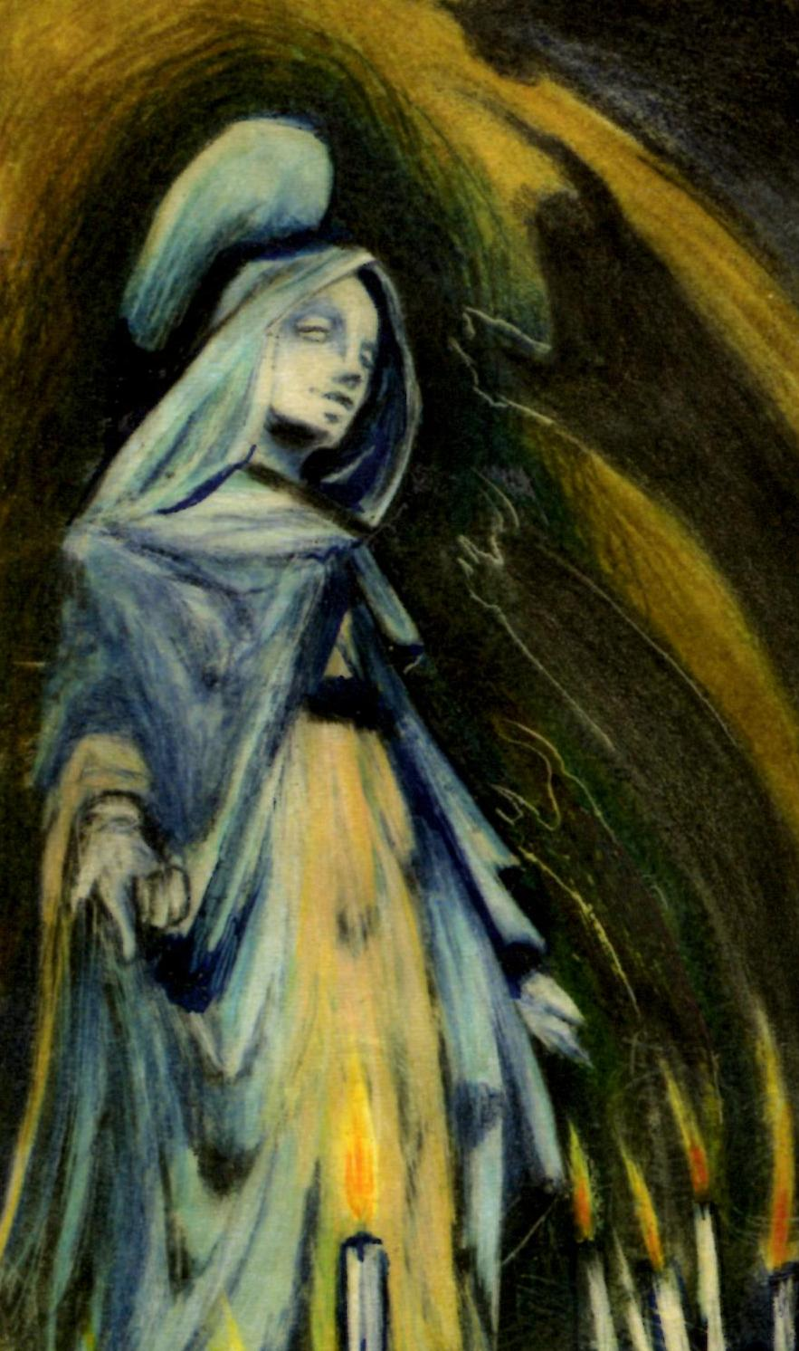

And yet the statue – the one they call ‘The Spirit of Naples’ - still stands candlelit in the Church of Santa Chiara, wisps of red hair creeping now and then from under her hood.

A warren of passages still weaves their way through the ancient foundations of the city, down and on down. Far below, Time sleeps, dark and whiskery, like a fat old black cat.
The only movements are the scurrying of rats, the pouncing of cats, the flutter of ghosts and – now and then – the glimmer of candles.

Strange little boy, shaped like a questions mark, is that you?

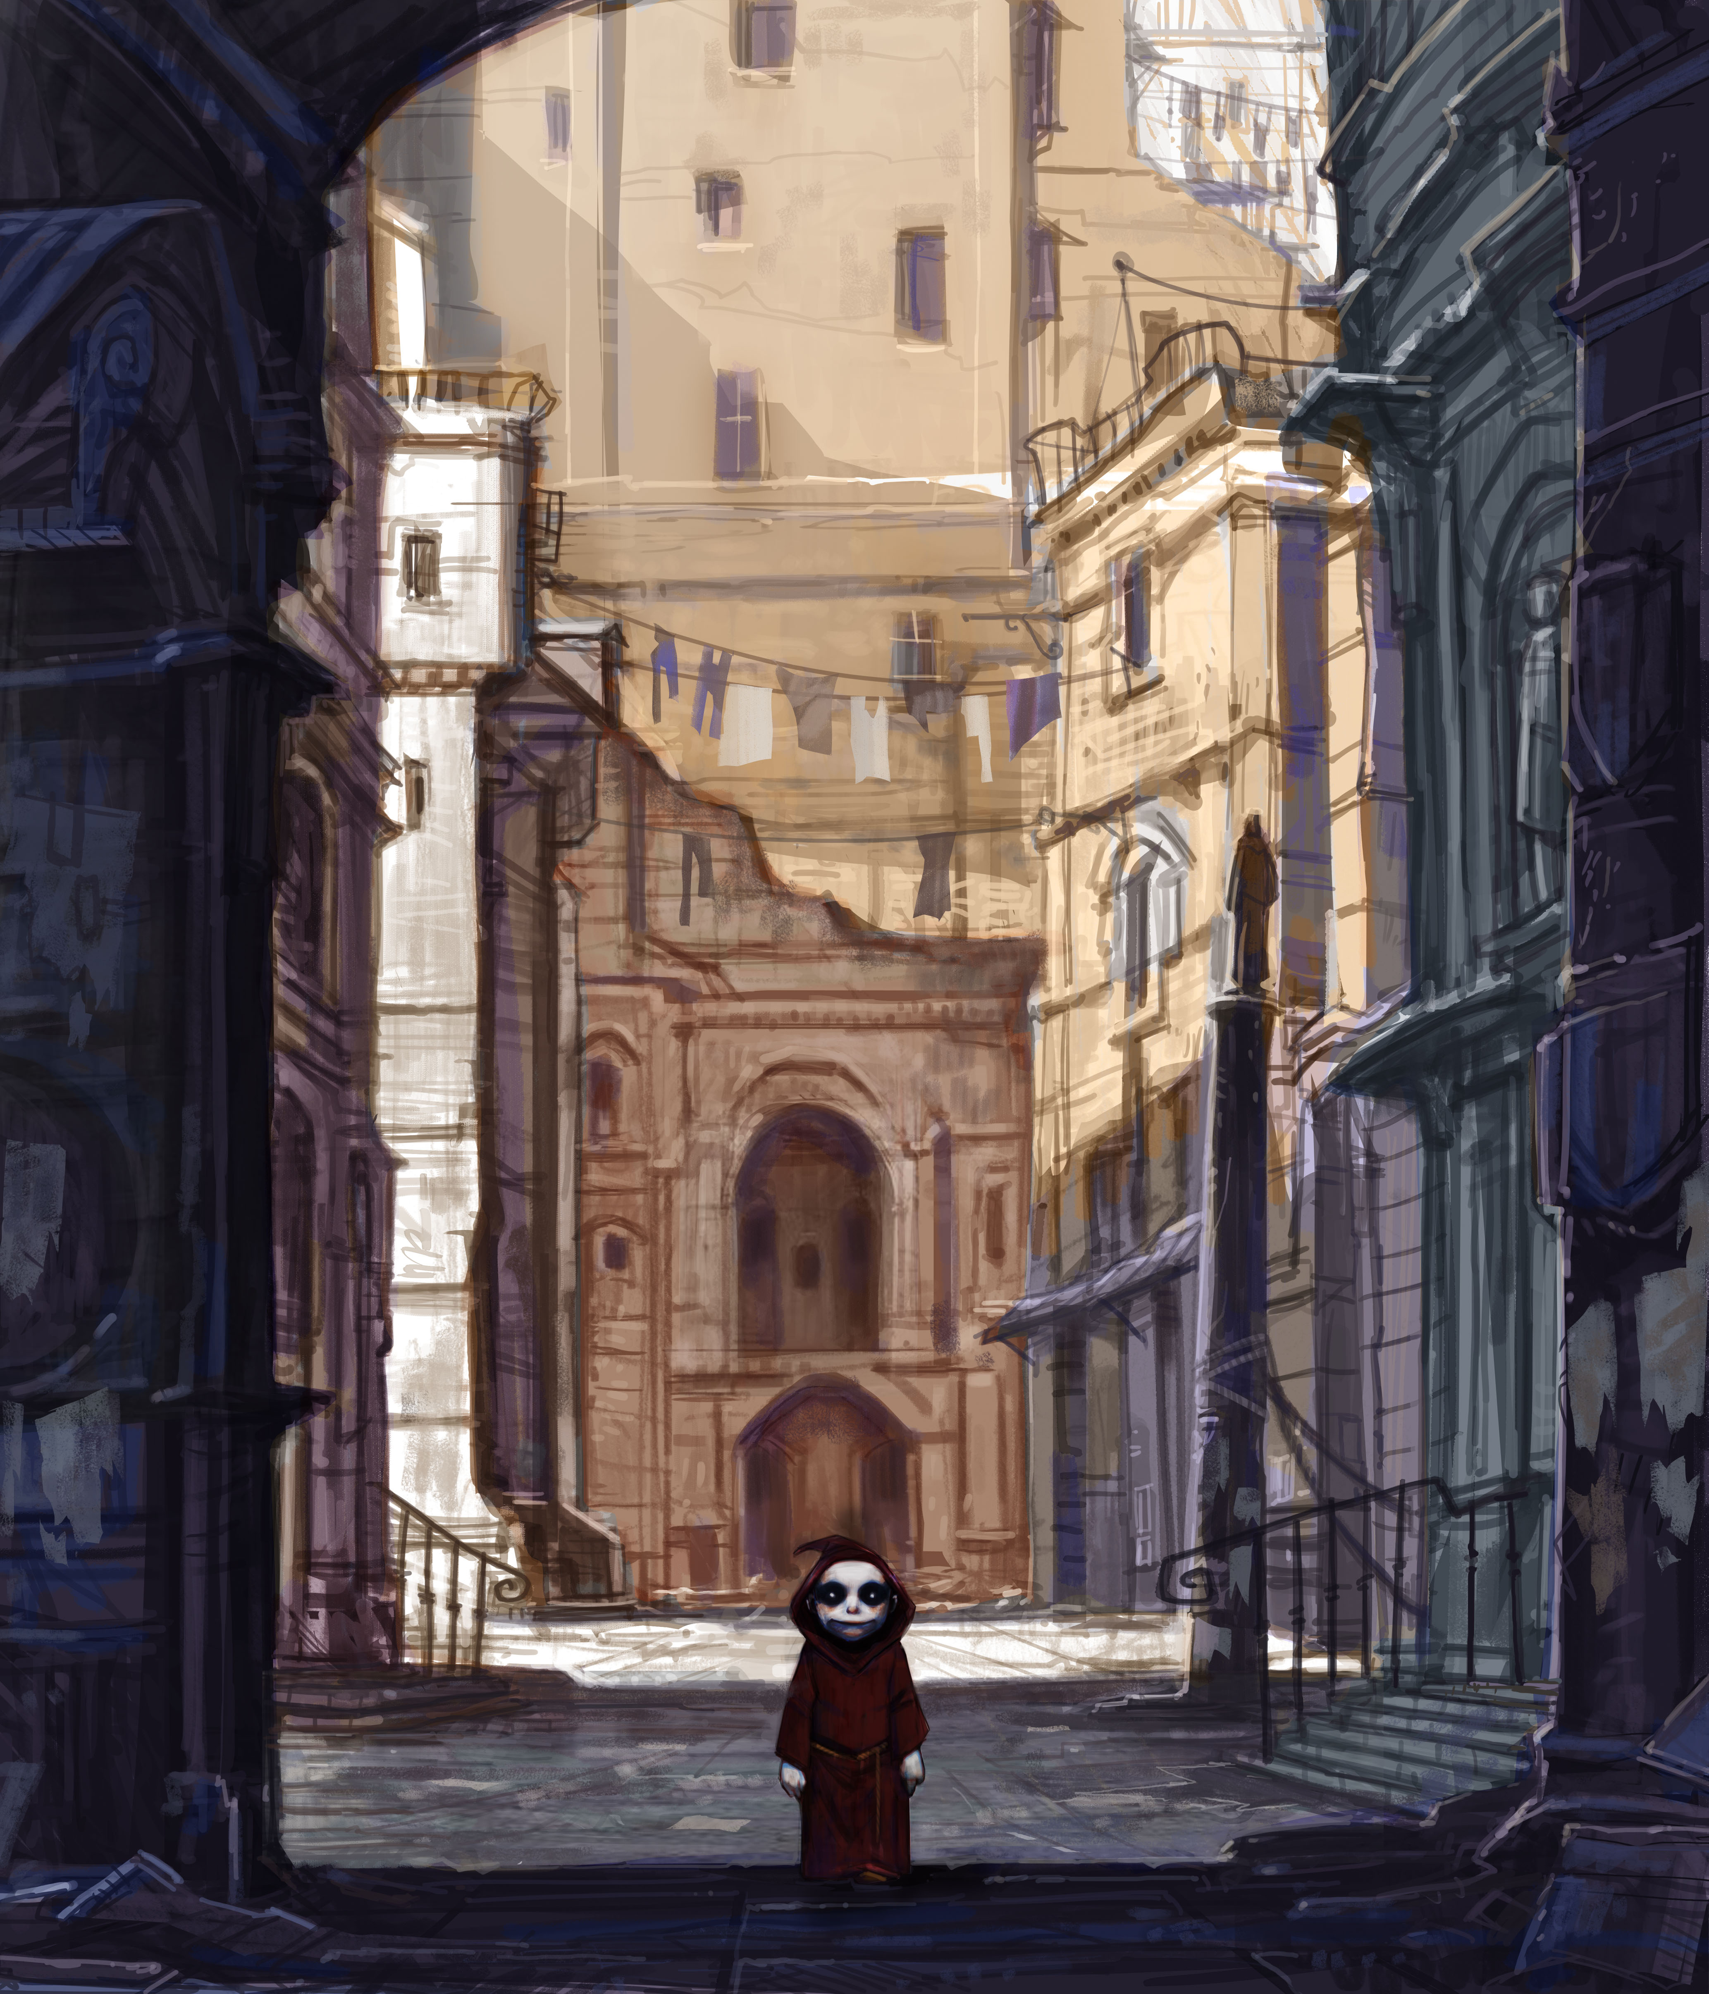
As Naples grew older, did you stay young?
Do you still scuff through the alleyways, making mischief?

People still blame you when the traffic ties itself in knots, when taxes bite, when the pasta sticks to the pan.
And people still wish on you –
“Monacello, let me win!”
“Monacello, bring me a sweetheart!”
“Monacello, make me well!”
So, you must still be there, mustn’t you?

You there! If ever you go to Naples, if you catch sight of a movement out of the corner of your eye, or see a cat watching you from a garden wall – be quick! - make a wish.

And I wish you may, I wish you might
have the wish you wish tonight.

© Geraldine McCaughrean

